**Name: Nikhil Jais**

**Roll No: 25**

**Batch: B**

**Date: 21-03-2022**

**NETWORKING & SYSTEM ADMINISTRATION LAB**

**Experiment No.: 1**

**Aim**

Install the latest version of Ubuntu on an Oracle VM Virtual Box.

**Procedure**

**STEP 1**: Installing Virtual Box.

* 1. Starting pop-up window for the installation.

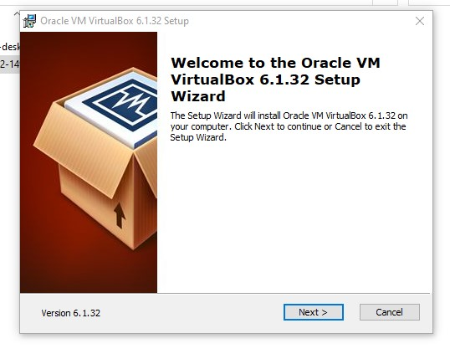

* 1. Custom setup window to select the features you want and select installation location.

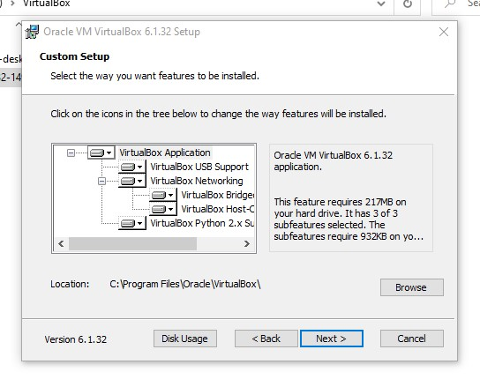

* 1. Custom setup window to choose from the option below.

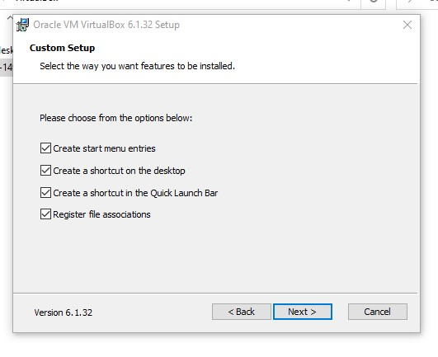

* 1. Custom setup window to confirm the installation.

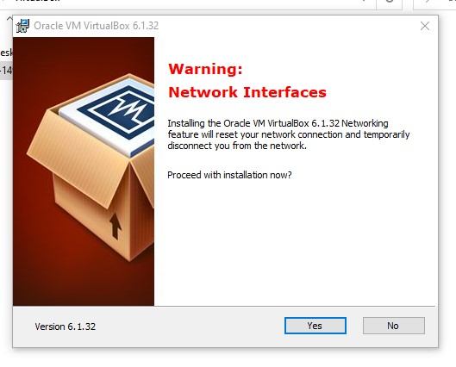

* 1. Custom setup window to install the virtual box with the install button.

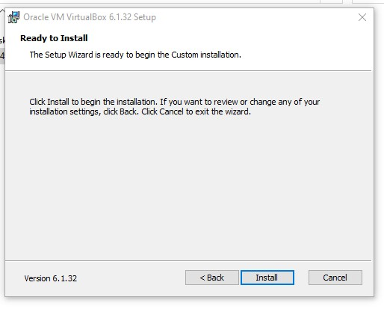

* 1. Installation box showing the installation status.

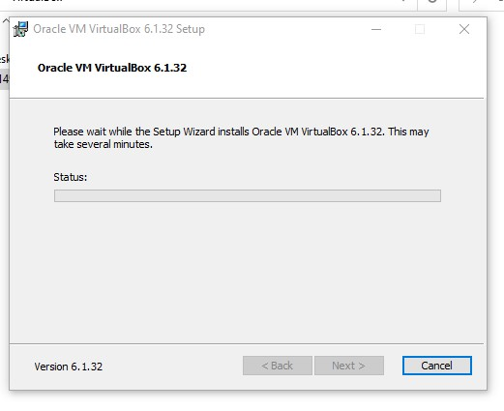

* 1. Installation complete pop-up windows with the finish button.

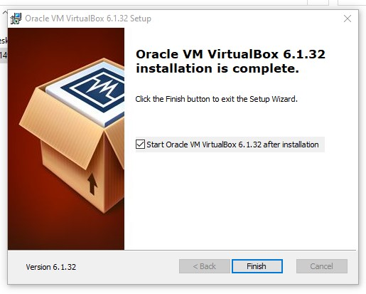

**STEP 2:** Setup the Ubuntu Instance in the VM Virtual Box.

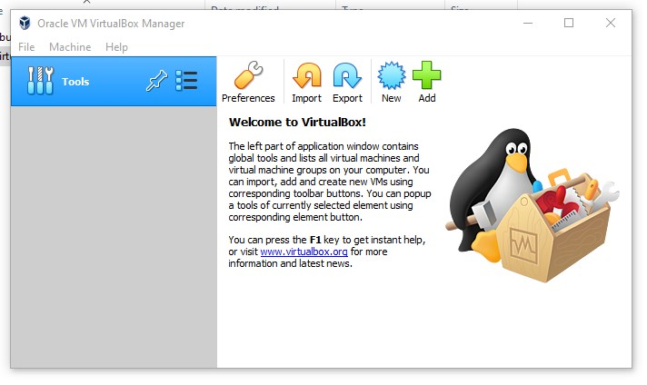

1. After selecting the NEW button to create the Ubuntu instance, the pop-up window to enter & select the name, type and version of the OS.

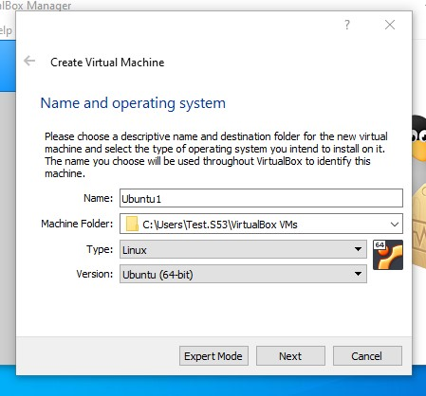

1. Choose the main memory size for the OS.

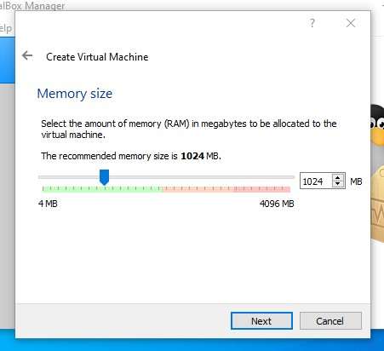

1. Option to add a virtual hard disk to the new machine instance.

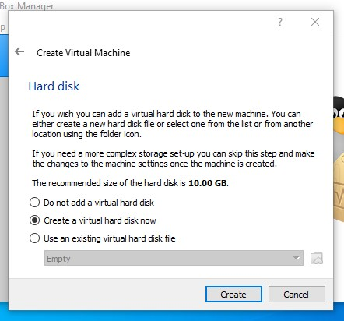

1. Option to choose the type of new virtual hard disk for new instance of OS.

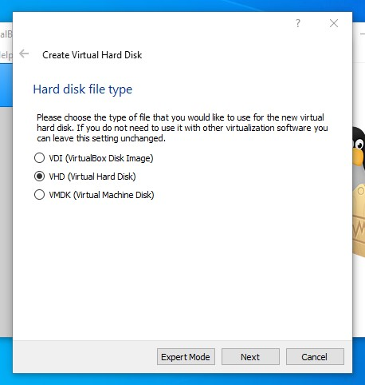

1. Options to choose the methods of accessing the physical hard disk space for the new instance from the existing hard disk.

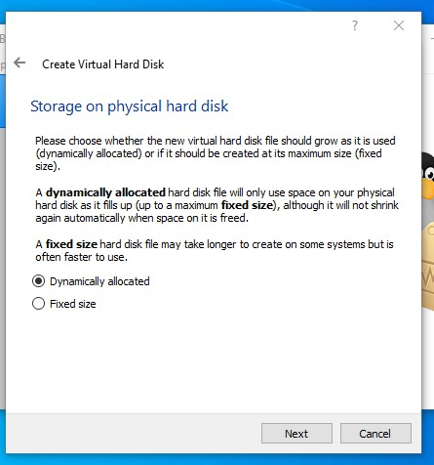

1. Panel to select the size of the virtual disk in megabytes and location and name of the instance and final submit to create the instance of OS.

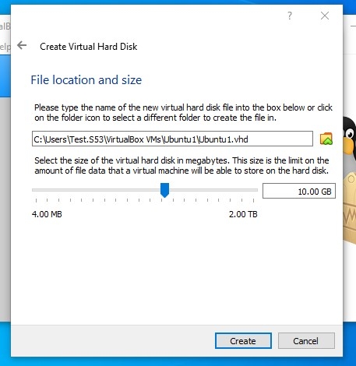

1. The newly created OS instance and at the left side of the application.

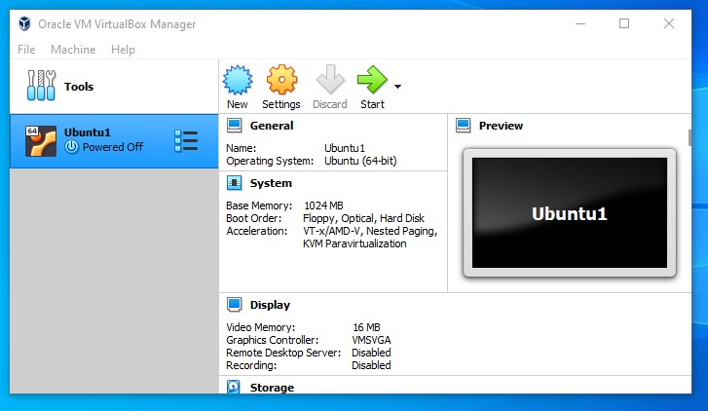

1. Settings the configurations of the instance created and adding the ISO image file of the OS correspondingly and Selecting the ISO image file from the local device.

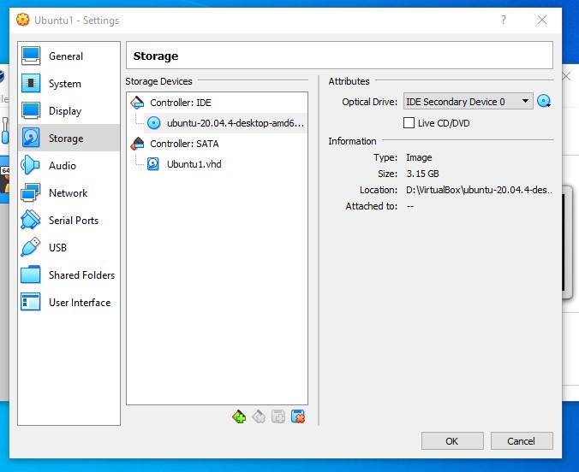

**STEP 3:** Installation of the Ubuntu OS within the newly created instance.

1. Running the new OS instance and selecting the “Install Ubuntu” to install the loaded ISO file.

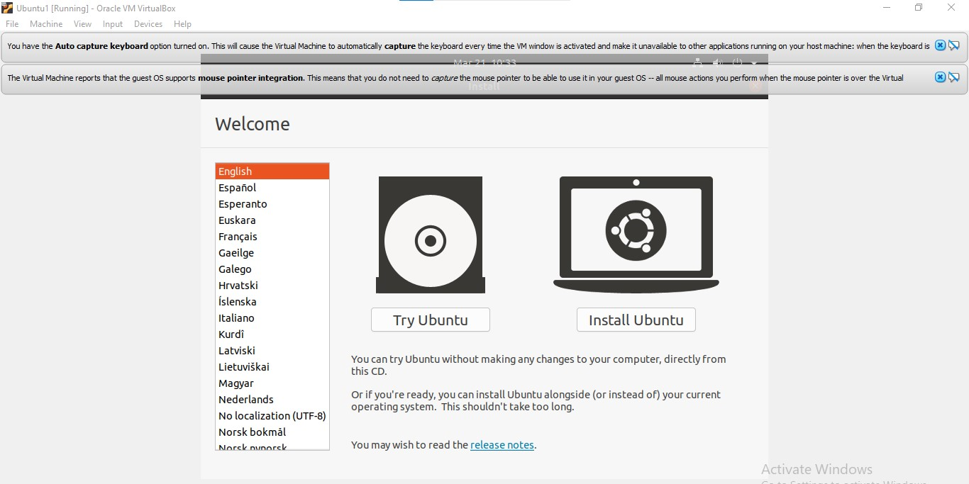

1. Selecting the language for install the ubuntu OS.

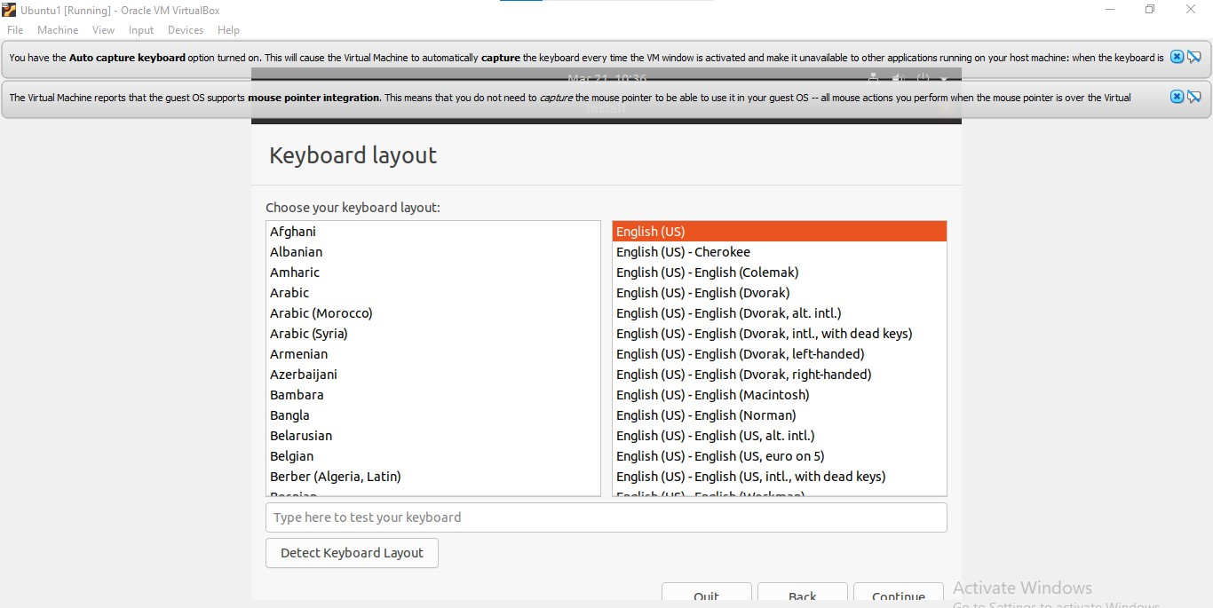

**c.** Selection of other installation along & within with the installation of ubuntu.

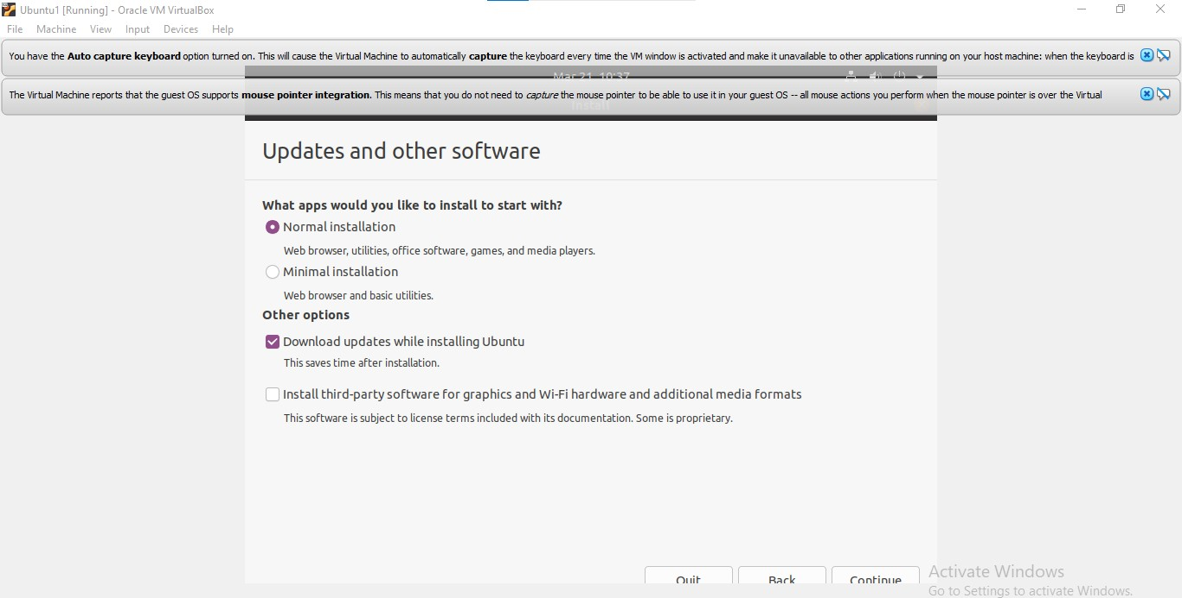

1. Selecting the disk partitioning allocation options from the given below.

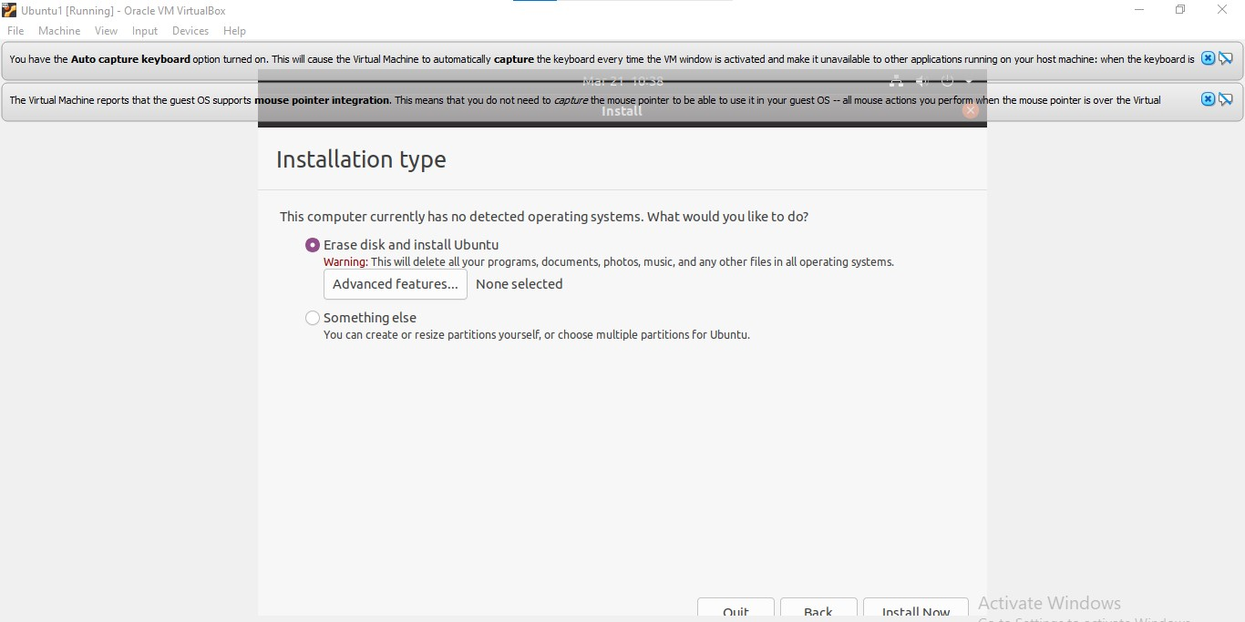

1. Selecting the geographical location for the time/location.

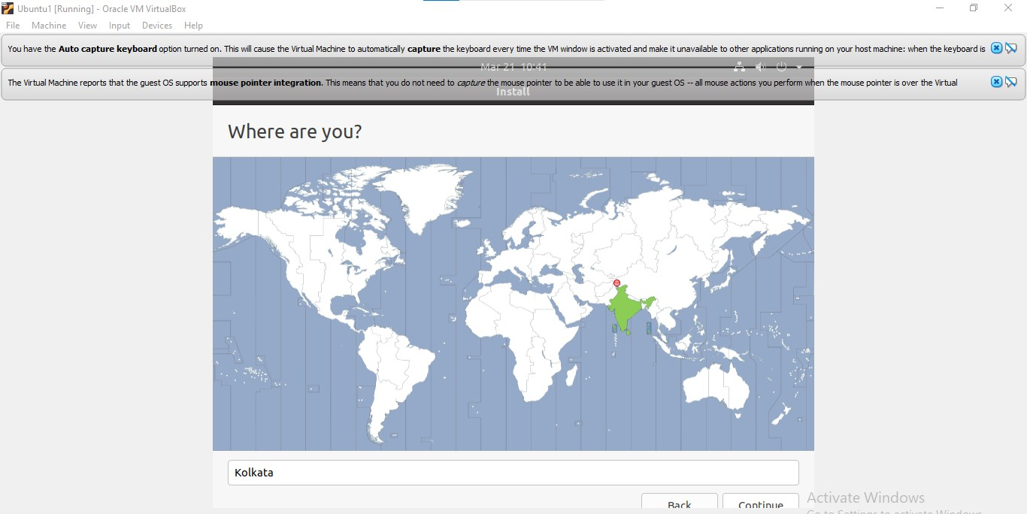

1. Entering the name, username & password for the account to sign in to the ubuntu OS after installation.

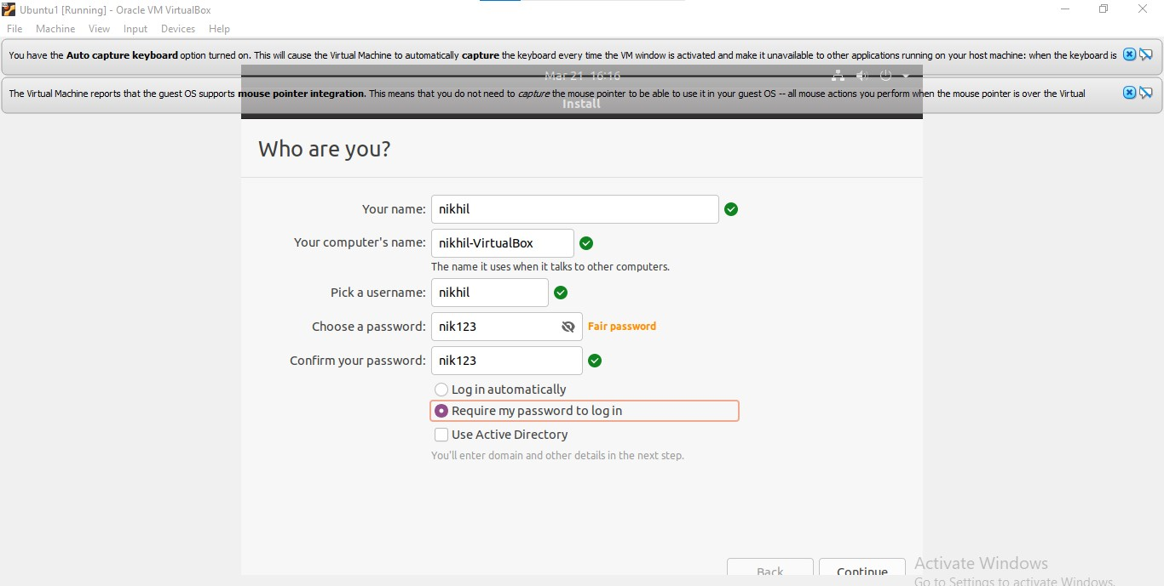

1. Installing the ubuntu OS in the instance, extracting the ubuntu ISO file, setting configurations, setting the various software within, etc.

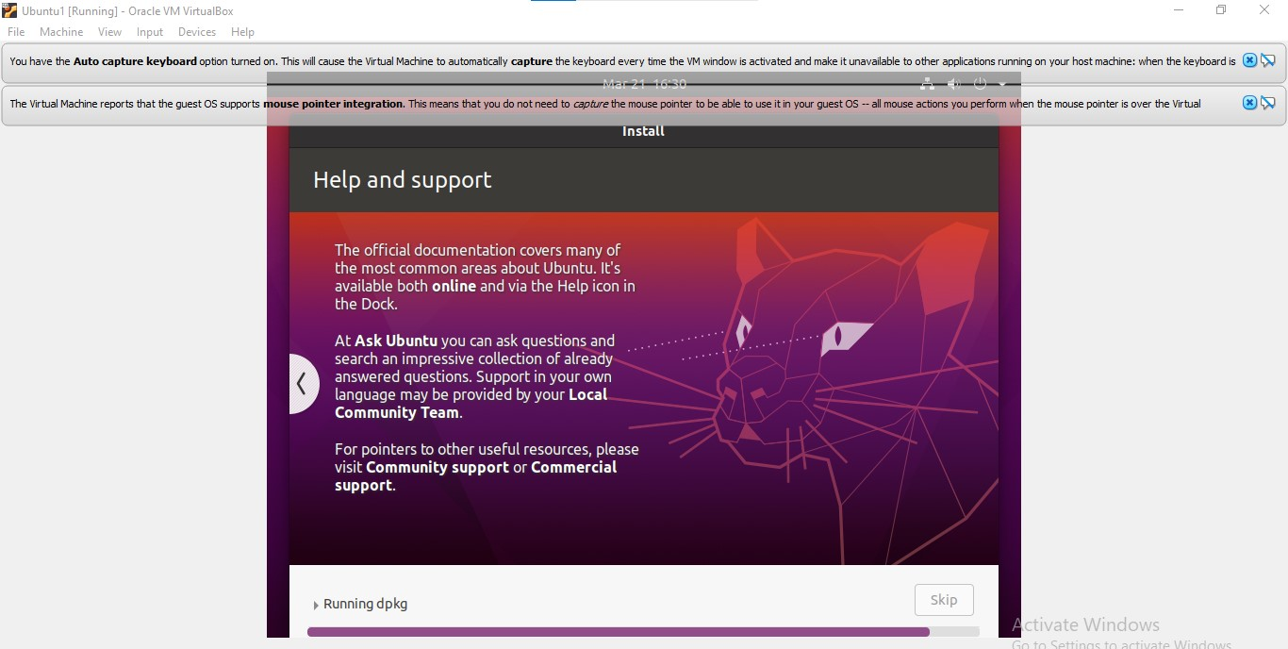

1. Restarting the OS instance to finalize the installation.

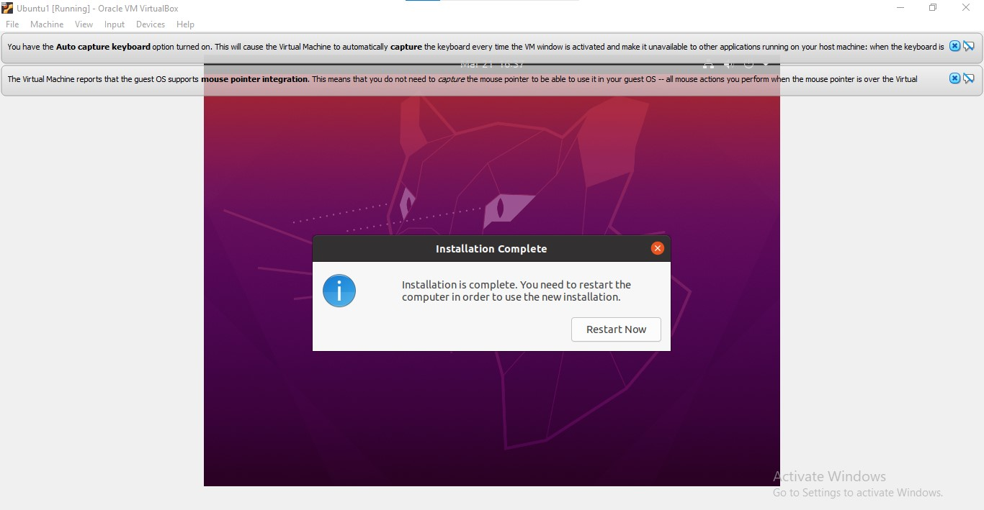

1. Signing in and visiting the home screen of the ubuntu OS using the previously registered username & password.

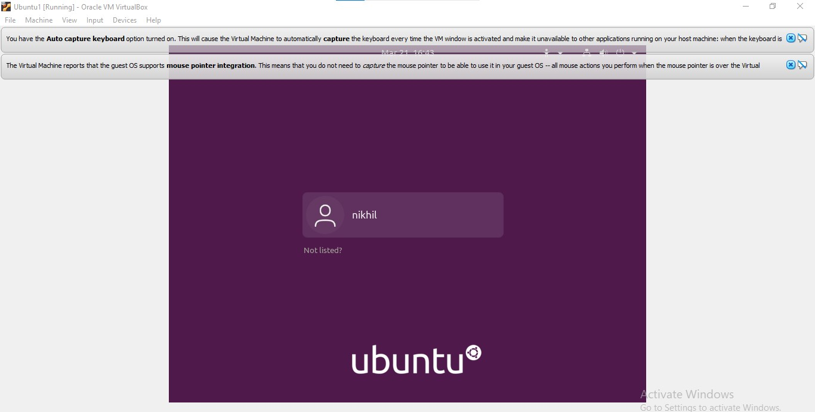

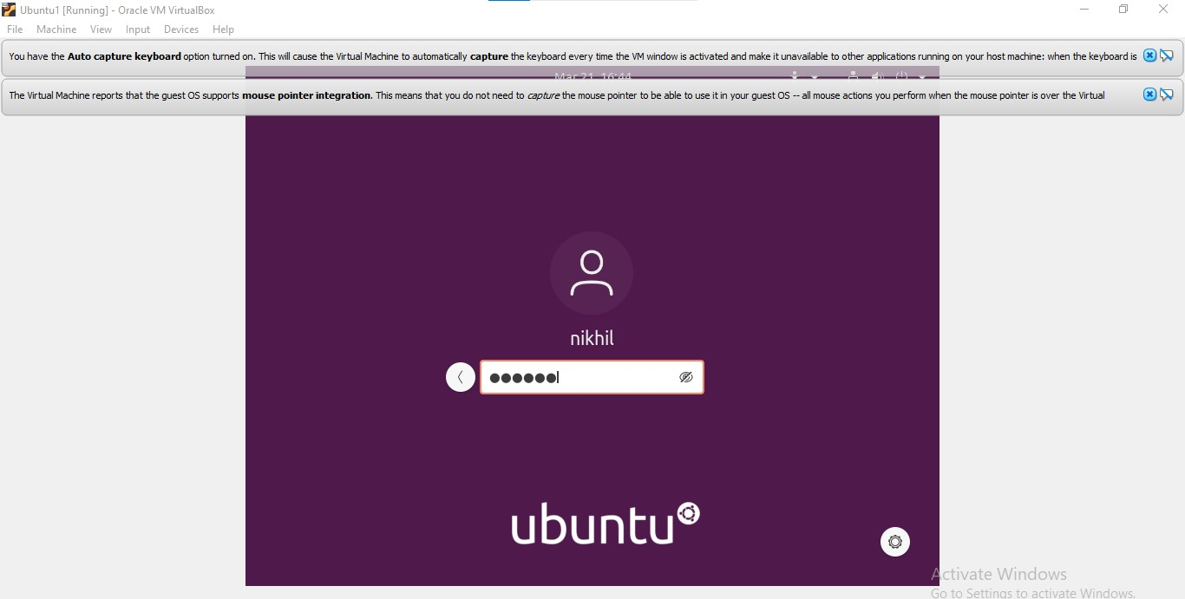

**Output Screenshot**

